**NETWORK ENUMERATION DEMO**

**Introduction**

If we want to hack a computer, we must know a few things.

Before anything else, we need to know that the computer exists in the first place - it’s hard to hack a computer that doesn’t exist. We also need information about the computer, and the more we have, the better. At a minimum, we’ll want to know what operating system and software the computer is running so that you can start looking up potential exploits.

One of the ways we can gain information about computers is through **Network Enumeration** (also known as **Network Scanning**). Network enumeration is an incredibly useful reconnaissance tool that can tell us what computers exist on a network and provide information about what those computers are. We can think of network enumeration like sonar or radar, sending out a pulse (or a packet of data in this case) and seeing what comes back. Also, like sonar and radar, network enumeration can make a lot of noise, and doing it recklessly will alert defenders to your activity.

Network enumeration can also be used for defensive or utility purposes, such as creating network diagrams or finding misconfigured computers.

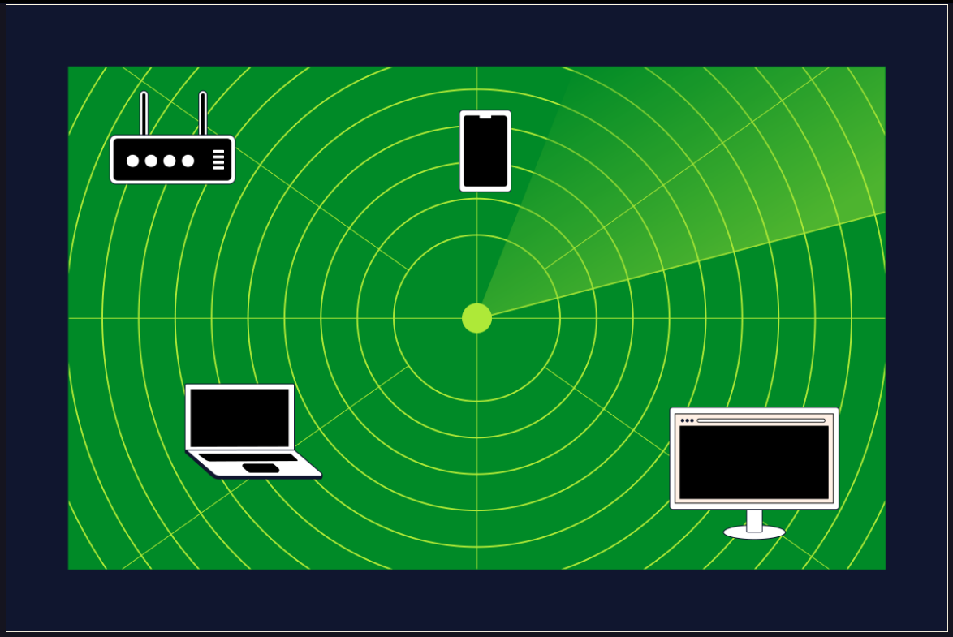

### Ports and You

An important concept to understand for network enumeration (and networking in general) is the concept of **ports**. Ports are to IP addresses, what apartment numbers are to street addresses. Ports don’t specify which computer the data gets sent to, but the computer uses the port number to figure out which program to give the data to once the data arrives. Knowing what ports a computer has active can give us an idea of what services the computer is running and what the computer’s purpose is.

Here’s a summary of the most important things to know about ports:

* There are 65536 different ports, numbered 0-65535.
* Ports 0-1023 are reserved for the most important or well-known protocols.
* Ports 1024-49151 are associated with less common protocols and services.
* Ports 49152 and up are dynamic and can be used as needed.
* Ports can be open or closed. Ports are closed by default but are opened when a computer runs a service that uses that port.
* Services can run on ports other than the port they are associated with by default. Likewise, services can run on ports associated with different services if configured. This can be used defensively to make network enumeration more difficult or offensively to obfuscate malicious connections.

Don’t worry about memorizing specific port numbers for now! We’ll provide relevant port numbers as needed for this lesson.

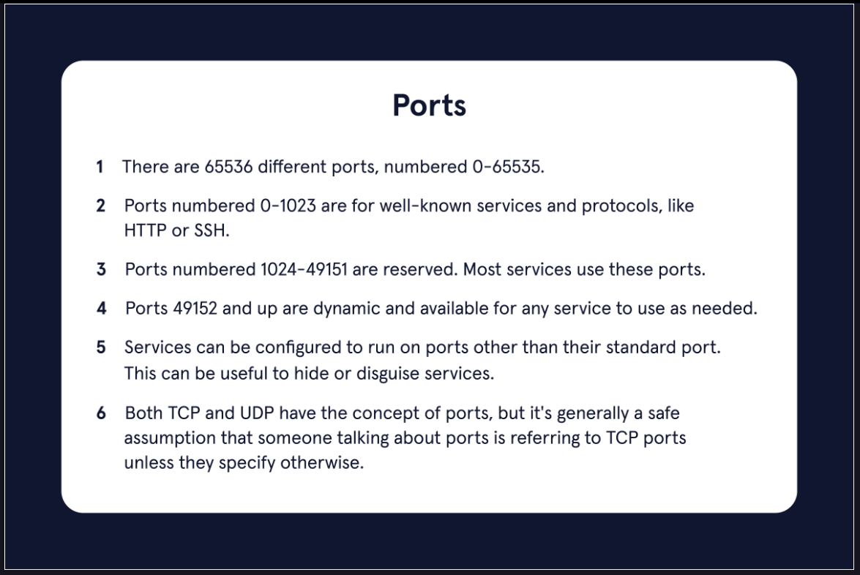

**Time to Scan**

The situation is as follows: One of the computers in a network has been infected with [malware](https://www.codecademy.com/resources/docs/cybersecurity/malware).

*Our task is to use network enumeration to determine which computer is likely to be infected so the computer can be wiped. We know the malware opens a port while it runs, but we don’t know which port.*

In this exercise, we’ll use [Nmap](https://www.codecademy.com/resources/docs/cybersecurity/nmap), a popular network scanning/enumeration tool, to identify which computer needs to be wiped. We’ll be using IP addresses in 10.1.1.x range for demonstration purposes.

*Before we begin our discovery, here are a few things to note:*

* Nmap, Network Mapper, is a port scanner/network mapping tool. It is the most used scanning tool by ethical and unethical hackers. The tool scans systems/networks for IP addresses, ports, OS details, and applications/services installed.
* Nmap is an open-source command-line tool designed to run on the Linux operating system (OS).
* Nmap is an open-source tool that is open to the public to use and improve on.

***Note:*** *Some of these services are not running on this box, so we have faked some terminal interactions in this specific exercise. This is so you can experience how these commands work in the real world.*

**Instructions**

Checkpoint 1 Passed

**1.**

Let’s start by using nmap to scan this box! What services are running in this lesson?

We can use the basic command nmap [target] to scan a target. In this case, localhost is our target.

Use the command:

nmap localhost

Hint

Type and run the command nmap localhost in the terminal.

Checkpoint 2 Passed

**2.**

Great! We’ve scanned our target and identified a list of running services.

It would be nice to see how many computers are on our part of the network. Let’s scan the wider network to find out! (The easiest way to do that is by pinging every address.)

We can use the command:

nmap -sn 10.1.1.0-255

to ping every address in our desired range.

* The -sn parameter specifies that we want to use ping scanning.
* 10.1.1.0-255 means we want to scan this range of addresses.

Hint

Type and run the command nmap -sn 10.1.1.0-255 in the terminal.

Checkpoint 3 Passed

**3.**

It looks like there are four hosts, not including ourselves, on the network.

We discovered hosts up at these addresses:

* 10.1.1.21
* 10.1.1.22
* 10.1.1.23
* 10.1.1.24

We know that the hosts exist, but not much more than that. Let’s run a more intensive scan, targeting the four hosts specifically.

Use the command:

nmap -sS -T4 --top-ports 1000 10.1.1.21-24

to scan the 1000 most commonly open ports on our targets.

* T4 specifies that this will be done fairly quickly.
* sS is short for “stealth scan” (which is not very stealthy these days).

Hint

Type and run the command nmap -sS -T4 --top-ports 1000 10.1.1.21-24 in the terminal.

Checkpoint 4 Passed

**4.**

Now, we’re starting to get a good picture of the hosts!

Notice that the host on 10.1.1.24 has ports 80 and 443 open. These ports are associated with the HTTP and HTTPS protocols, indicating that this might be a server.

Servers are high-value targets, so this would be a good candidate for further investigation.

We can scan every port on this specific target using the command:

nmap -p- 10.1.1.24

Hint

Type and run the command nmap -p- 10.1.1.24 in the terminal.

Checkpoint 5 Passed

**5.**

Hmm, port 12345 looks a bit odd…

12345/tcp open netbus

Further investigation reveals that it’s associated with the **NetBus Remote Access Trojan**. Looks like we’ve found our malware!

Press Enter in the Terminal to complete this checkpoint.

Then select Next to continue with the lesson.

Hint

Google is your friend when you’re trying to figure out what service a port is associated with, or what a service does!

To pass this checkpoint, click on the Terminal and press the Enter key.

## Terminal

bash

$ nmap localhost

Nmap scan report for localhost (127.0.0.1)

Host is up (0.000078s latency).

Other addresses for localhost (not scanned): ::1

Not shown: 996 closed ports

PORT STATE SERVICE

22/tcp filtered ssh

2121/tcp open ccproxy-ftp

4000/tcp open remoteanything

8000/tcp open http-alt

Nmap done: 1 IP address (1 host up) scanned in 2.58 seconds

$ nmap -sn 10.1.1.0-255

Starting Nmap 7.80 ( https://nmap.org )

Nmap scan report for my_computer (10.1.1.20)

Host is up (0s latency).

Nmap scan report for 10.1.1.21

Host is up (0s latency).

Nmap scan report for 10.1.1.22

Host is up (0s latency).

Nmap scan report for 10.1.1.23

Host is up (0s latency).

Nmap scan report for 10.1.1.24

Host is up (0s latency).

Nmap done: 256 IP addresses (5 hosts up) scanned in 0 seconds

$ nmap -sS -T4 --top-ports 1000 10.1.1.21-24

Starting Nmap 7.80 ( https://nmap.org )

Nmap scan report for 10.1.1.21

Host is up (0s latency).

Not shown: 998 closed ports

PORT STATE SERVICE

22/tcp open ssh

161/udp open snmp

MAC Address: 5E:0F:E4:9A:13:D2 (unknown)

Nmap done: 4 IP addresses (4 hosts up) scanned in 0 seconds

Nmap scan report for 10.1.1.22

Host is up (0s latency).

Not shown: 998 closed ports

PORT STATE SERVICE

22/tcp open ssh

161/udp open snmp

MAC Address: 05:05:50:88:9E:38 (unknown)

Nmap scan report for 10.1.1.23

Host is up (0s latency).

Not shown: 998 closed ports

PORT STATE SERVICE

22/tcp open ssh

161/udp open snmp

MAC Address: BE:63:43:7D:05:80 (unknown)

Nmap scan report for 10.1.1.24

Host is up (0s latency).

Not shown: 996 closed ports

PORT STATE SERVICE

22/tcp open ssh

80/tcp open http

161/udp open snmp

443/tcp open https

MAC Address: 0D:32:BC:1B:28:7F (Servers R Us)

$ nmap -p- 10.1.1.24

Starting Nmap 7.80 ( https://nmap.org )

Nmap scan report for 10.1.1.24

Host is up (0s latency).

Not shown: 65529 closed ports

PORT STATE SERVICE

22/tcp open ssh

80/tcp open http

161/udp open snmp

443/tcp open https

12345/tcp open netbus

MAC Address: 0D:32:BC:1B:28:7F (Servers R Us)

Nmap done: 1 IP address (1 host up) scanned in 3 seconds